# Book

## Post

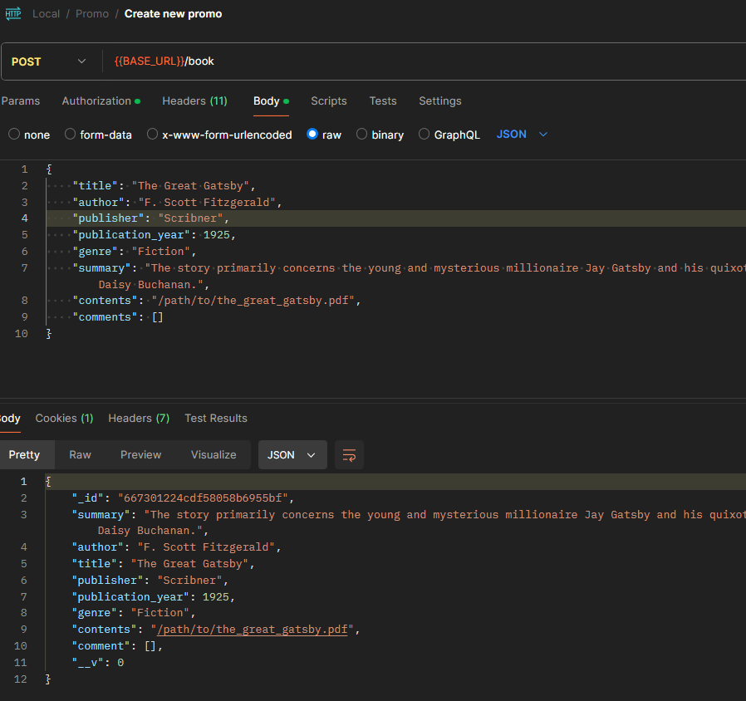

## GET

# Book ID

## Put

## Delete

## GET

# Comments

## Post

## Get

## Get Populated

# Comment details

## Get

## Delete

## Put

